Module 2 SIZE

Why work on tax? Thinking about doing advocacy on tax justice

Aim of exercise
To begin to explore why taxation is relevant to the work of your network.

Activity

This exercise is intended to get you thinking about why you and your organisation might want to work on tax justice issues.
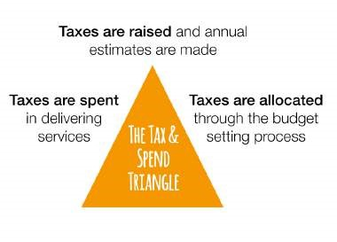
Step 1: Think about why taxation is relevant to your organisation, union, network or community, by considering the questions below:

- Look at the tax triangle. What work are you currently doing on the triangle?
- As an education advocate, can you make a compelling case for working on tax and/or where the money for education should come from?
- What obstacles might get in the way of making the case for fair tax to fund education? For example, is there a negative view of taxation in your country? Would your advocacy need to overcome negative perceptions? What messages would you need to develop to overcome these obstacles?

What to do in a workshop setting
Time allowed: approximately 1 hour to prepare + feedback 20 minutes per group
If some of the participants are relatively new to this topic and you want to get them to start thinking about the meaning of fair tax, before embarking on the exercise, you could use one of the introductory activities from ActionAid’s Tax Power Reflection-Action Toolkit (ActionAid, 2015b) such as the Tax Stones, for example.
Ask participants to work in groups on the questions above and prepare feedback to make a case for working on tax justice in their context.
Give feedback as role play – with participants presenting the case to their organisation or board members.

